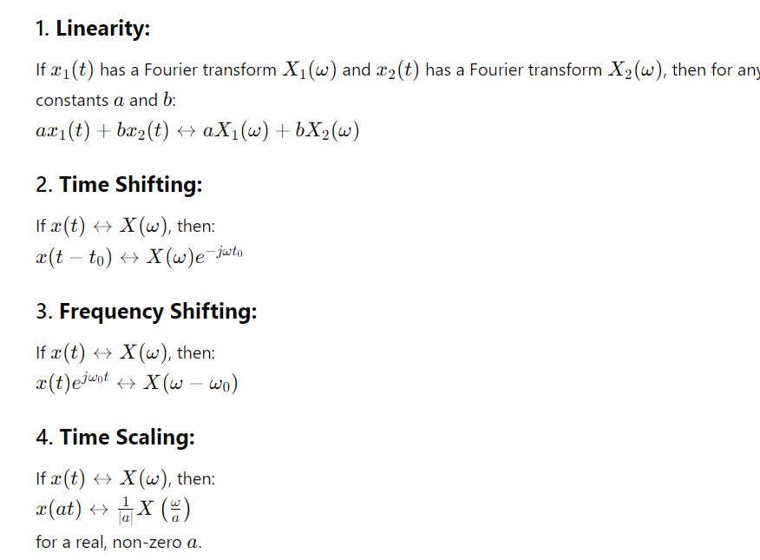

Continuous time FT:

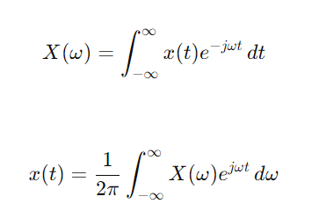

Discrete time fourier transform:

